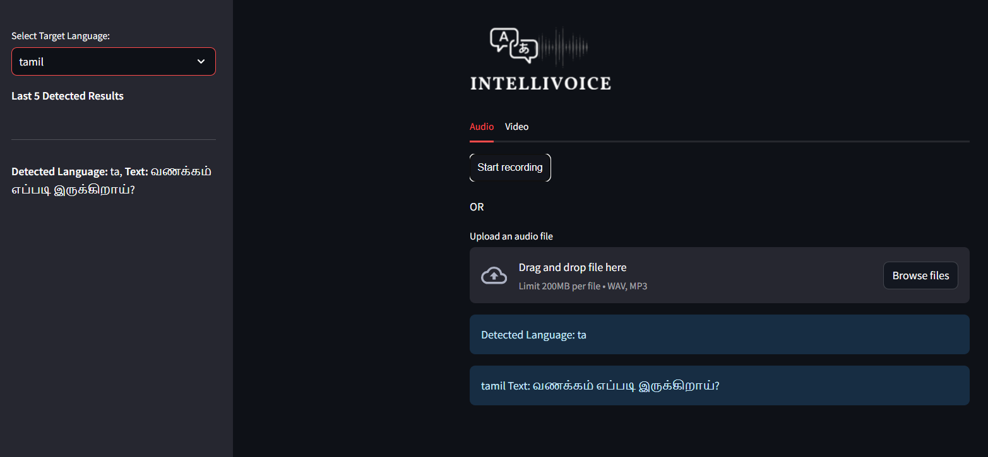**Tamil Language Detection**:

**Warning: When Target Language and Detected Language is not equal.**

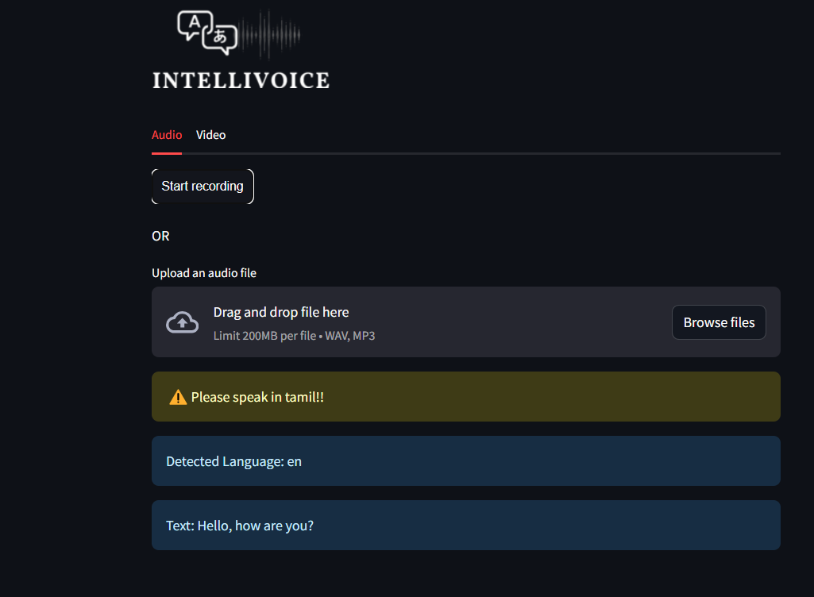

**Gujarati Language Detection:**

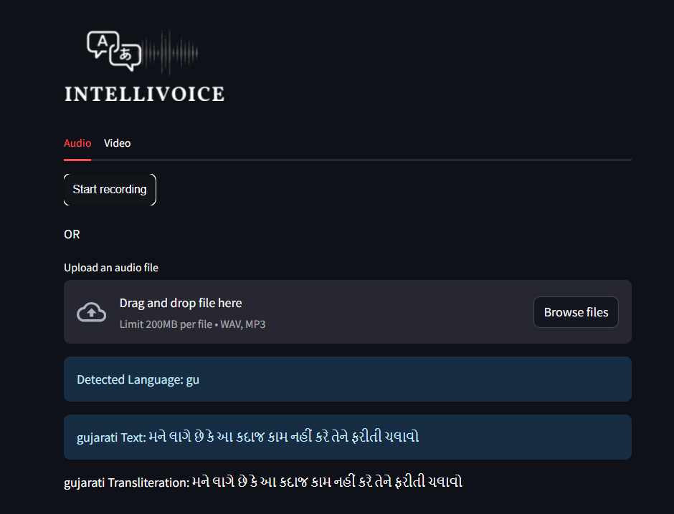

In this we also had perform the transliteration from another language’s token to Gujarati token. Transliterating to **Devnagari Speech**. This is the mapping, encoding scheme where various characters are associated with numerical values. The characters seem to be from the Devanagari script, which is used for writing several languages, including Sanskrit, Gujarati. Each Devanagari character is associated with a numeric value. For example, **"\u0915"** corresponds to 4, **"\u0936"** corresponds to 5, and so on. Additionally, there are some non-Devanagari characters such as "f", "s", "k", "&", "w", "t", "n", "d", "s", "q", "x", "y", "g", "z", "j", "v", "o", "m", "u", "l", "i", "e", "c", "r", "h", "a", "b", and "p", each associated with a numeric value. The **special tokens** like "[UNK]" and "[PAD]" also have numeric representations. Some characters may represent punctuation marks like "\u0964" (which is a **Devanagari Danda** or full stop).

**Hindi Language Detection:**

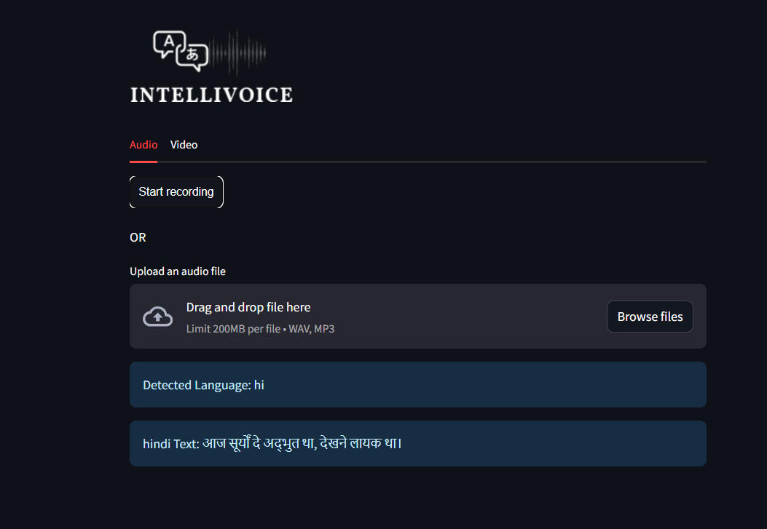

**Marathi Language Detection using audio file input (From Kaggle Dataset):**

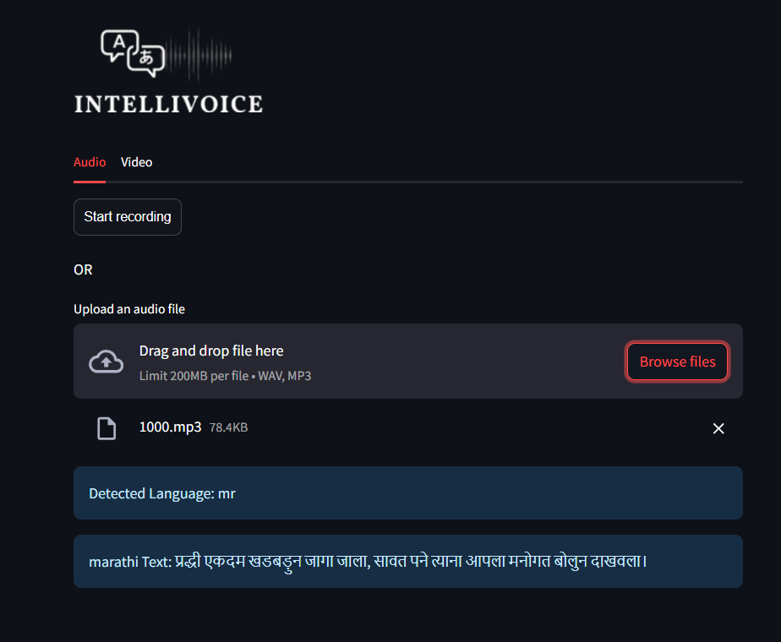

**Bengali Language Detection using audio file input:**

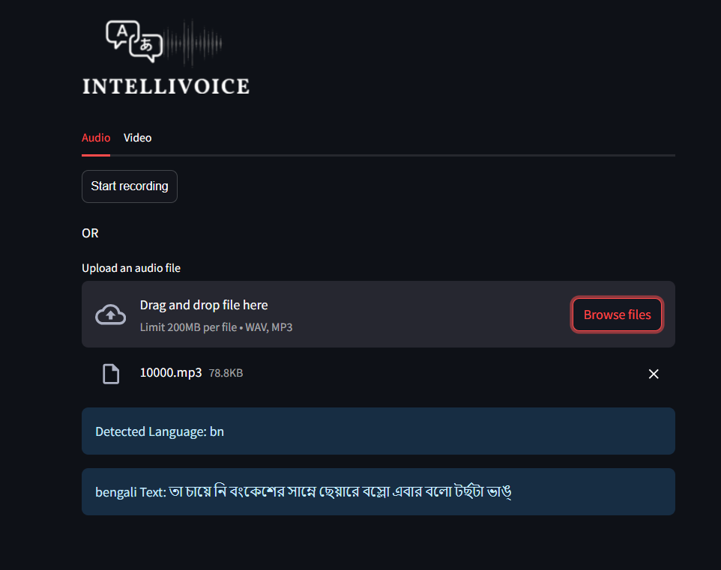

**VIDEO INPUT**

**Hindi Language Detection:**

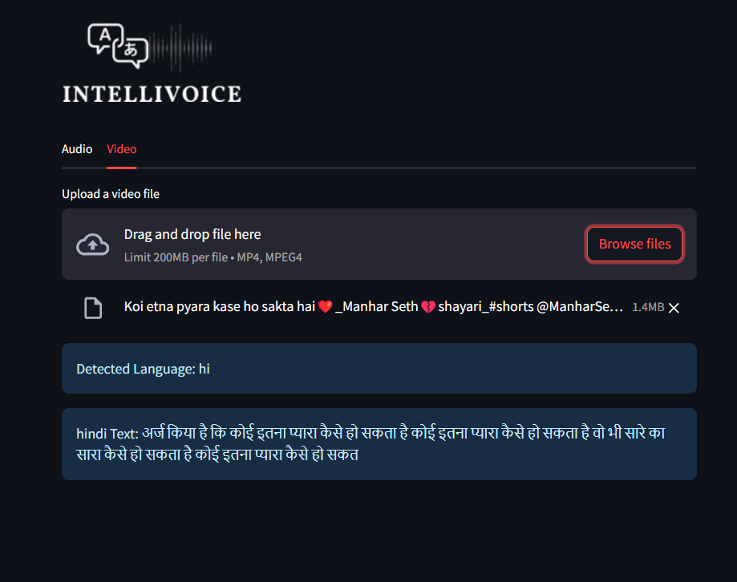

**English Language Detection:**

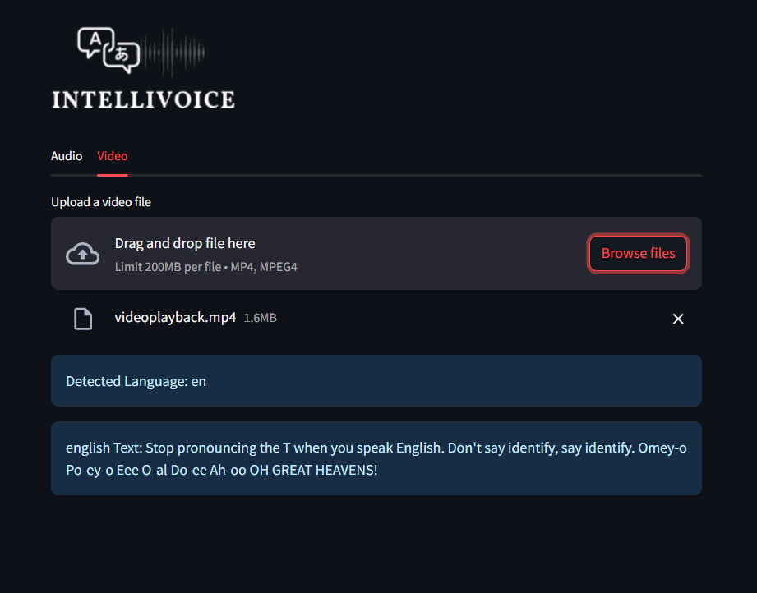

**SPEECH DETECTION WITH NOISE**

1] It translates the words correctly but language prediction is not correct as the noise padding is very high.

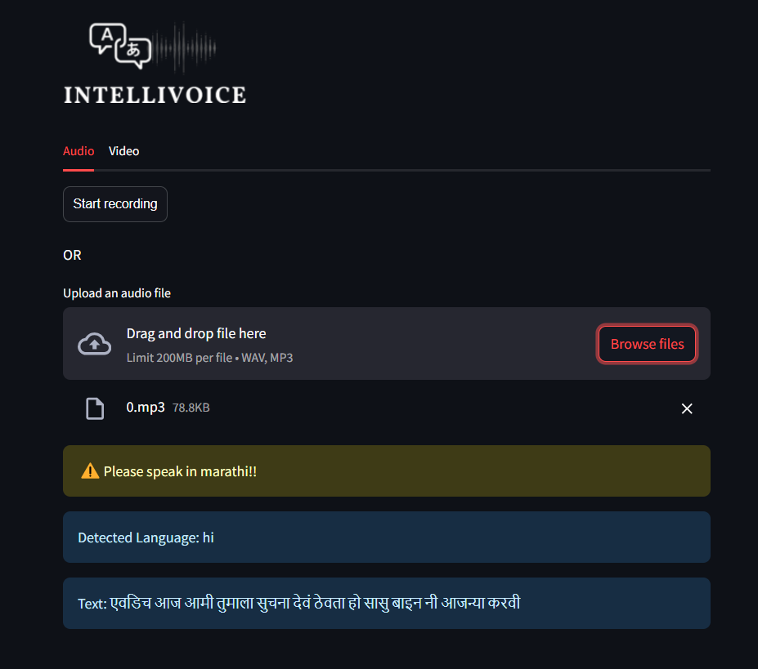

It predicts correctly with medium noise padding.

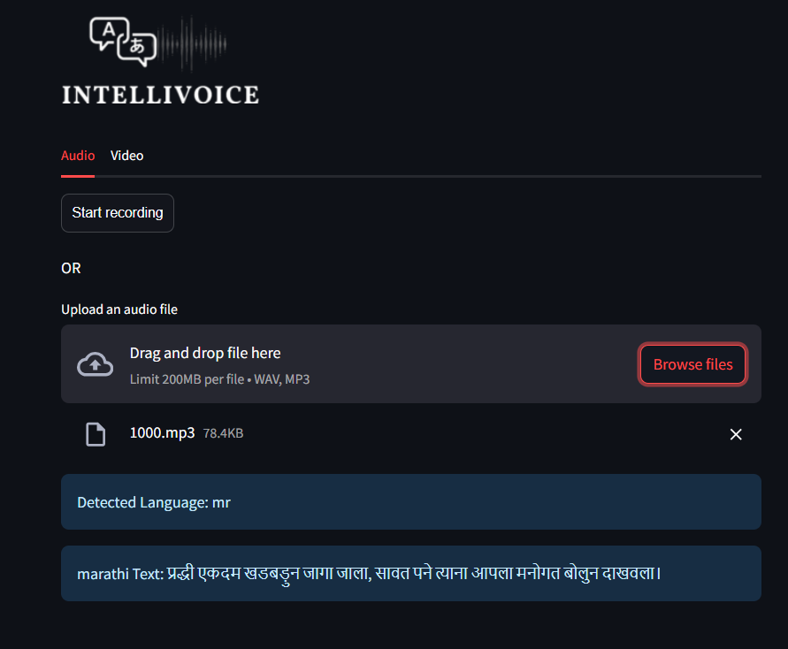

**SIDEBAR RECORDS (FOR HISTORY)**

